Web specifications
Introduction
KM gears is a website to display and sell quality shinguards at an affordable price. It provides users with simple user interface website. The name KM is from the initials of the founder which is kgotla Mokgachane, a brand focused on improving a football players performance.
Website objective
The main objective of the website is to sell and advertise high quality shinpads or guards at an affordable price under the website name KM gears.
Website goals
- Showcase the different types of shinguards for example, lightweights, protective and many more.

- For attraction, to gain and to be seen by big brand names and successful footballers who have a huge social media following for collabs.

- To provide information and user interface that would be easy for users to access and purchase products.

- To build a community of players that would share ideas, experiences and engage with the KM gears brand.

- Increase the sales and build trust between the customers and the brand for better building as a business.

Target Audience
The audience is targeted to mainly football players (both male and female ) and to football enthusiasts.
Demographics:
- Age group: 13–36 years
- Gender: All genders interested in football
- Location: Botswana and international markets
- Interests: Football, sports gear, and fitness

Technical Aptitude
- Users are familiar with smartphones, computers, and the internet
- Comfortable browsing websites and making online purchases
- Active on social media platforms and digital environments

Type of Website
KM gears will be an e-commerce website which sells a product called shinguards/shinpads.
Main focus
- Showcasing the football product(shinpad)
- Promotion of the Brand
- Flexible product prices.
- Safety gear to avoid injuries in games.

Information, design and taxonomy
Figure 1.0 below shows a sitemap of the website KM gears.
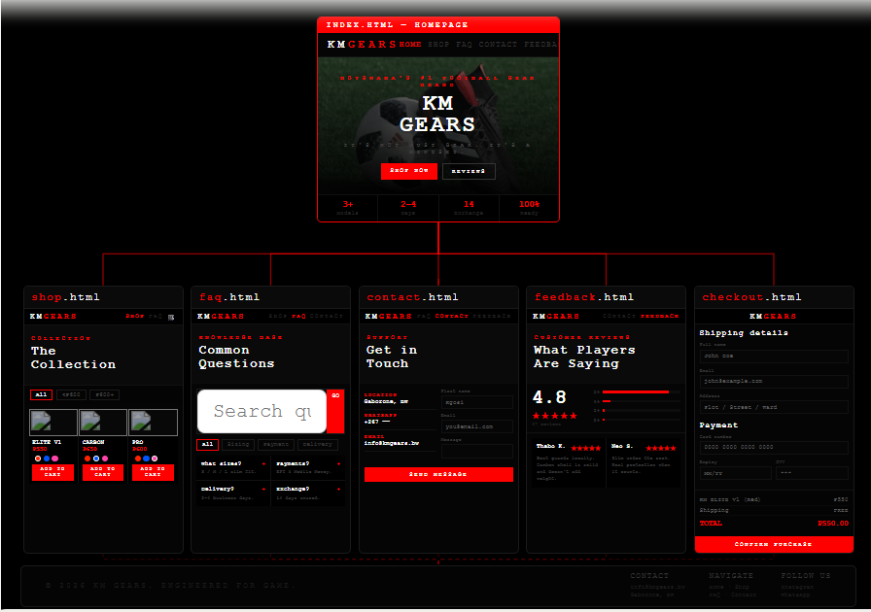

Figure 2.0 below shows the navigation flow of the website KM gears.

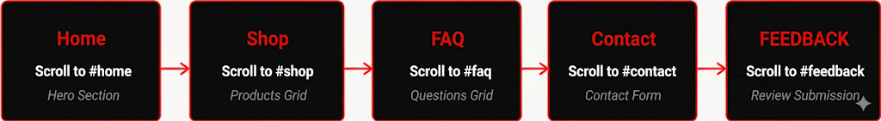

Figure 3.0 below shows the key interactive elements of the website KM gears.
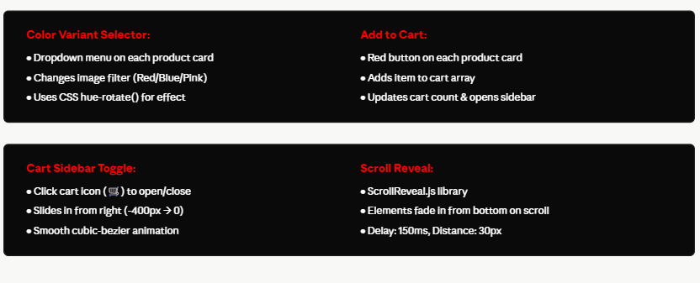

Technical brief

Overview
KM gears is a website strictly focused on selling and marketing shinguards. The website will provide the following :
- Product information.
- Pricing.
- Contacting about inquiries.

Technology used
HTML5
HTML5 stands for hypertext markup language 5, known as the 5th and UpToDate version of HTML used to present content on the world wide web and will be used to structure the web pages.

CSS3
CSS stands for cascading style sheet. it will be used to give the HTML and website styling and layout.
JavaScript
It is a programming language that implements complex features on webpages. It will be used For animations and feedback from the users.

Website Structure
The website will consist of the following :
- Global configuration and styling
- Navigation and header
- Sidebar charts
- Page sections
- Functional Logic
- Footer

Design requirements:
- Simple and clean Morden design.
- Consistent colour on all the webpages.
- Easy to navigate through.
- Browser compatibility.
- Mobile phone friendly.

Hardware and Software Requirements
Main Hardware that will be used is a laptop but it would be used on the phone too for testing responsiveness.
Software such as Microsoft edge and google chrome are to be used as well as notepad which is a text editor.

Constraints
- Limited to basic web technologies (HTML, CSS, JavaScript).
- No database integration.
- Limited development time.

Testing
The website would be tested for various factors such as browser compatibility, smooth transitions between pages, simple navigation throughout the pages, functionality of links and forms.

Promotion and publishing
Promotion
The website will be published using a web hosting platform. This will ensure that users can access the website through the internet using a web browsers.
The website would be tested across multiple os and websites to ensure everything runs smoothly and it compatible across multiple browsers and phones.
Publishing
The website would be published across various digital platforms such as TikTok Facebook, Instagram and etc to bring views and increase brand awareness and sales.

Wireframe of the Website
HOME PAGE
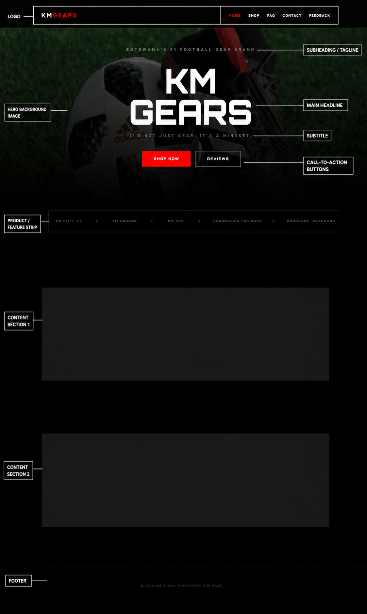

Primary Branding: The top of the page features a prominent logo area with the brand name "KM GEARS" in a stylized font.
Navigation Menu: A clear header menu provides links to essential pages: Home, Shop, FAQ, Contact, and Feedback.
The Hero Statement: * Tagline: Positioned at the very top as "Botswana’s #1 Football Gear Brand".
Main Headline: A large, bold "KM GEARS" title dominates the center.
Subtitle: Directly below the headline is the brand's mission statement: "It's not just gear. It's a mindset".

SHOP PAGE

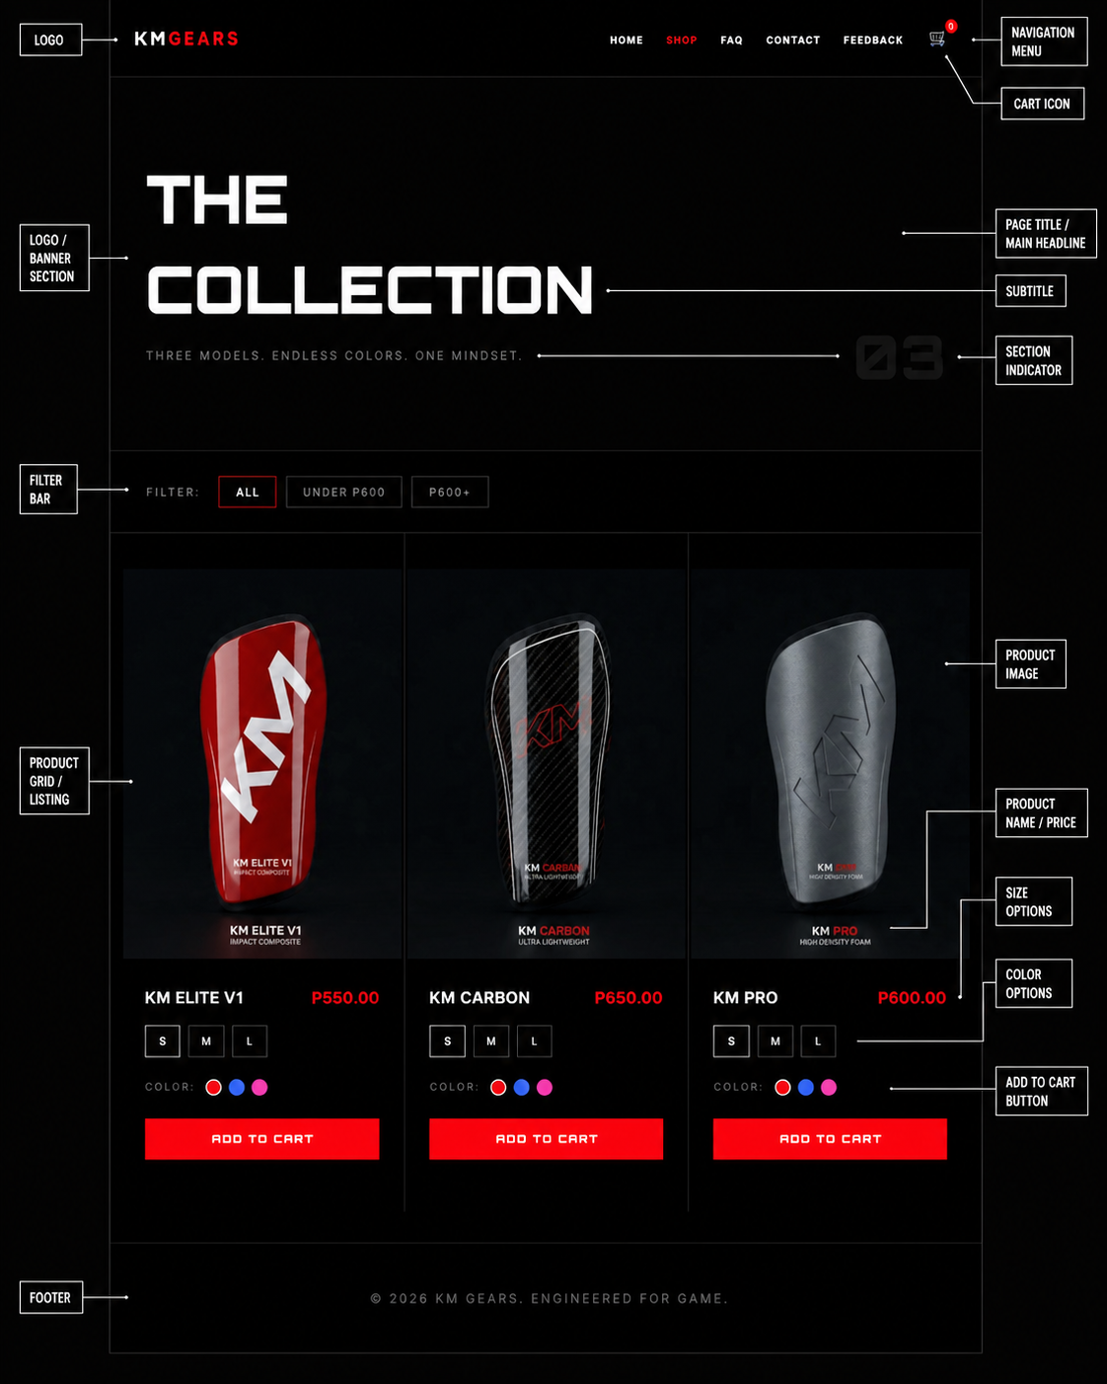
Page Header: Features the brand logo "KM GEARS" and a full navigation menu (Home, Shop, FAQ, Contact, Feedback) with a red notification badge on the shopping cart icon.
Main Headline: A large, bold title "THE COLLECTION" followed by the subtitle "THREE MODELS. ENDLESS COLORS. ONE MINDSET.".
Section Indicator: A subtle "03" graphic is placed in the background to indicate the page or section number.
Filter Bar: Includes options for users to sort products, such as "ALL," "UNDER P600," and "P600+".
Product Grid: Displays three main products in a side-by-side layout:
- KM ELITE V1 (Impact Composite): Priced at P550.00.
- KM CARBON (Ultra Lightweight): Priced at P650.00.
- KM PRO (High Density Foam): Priced at P600.00.
Product Interaction Features: Each item in the grid includes:
- Product Image: High-quality visuals of the specific shinpad model.
- Size Options: Selectable buttons for sizes S, M, and L.
- Colour Swatches: Interactive circles representing available colours (e.g., Red, Blue, Pink).
- Add to Cart Button: A bright red, prominent button for direct purchasing.

FAQ PAGE
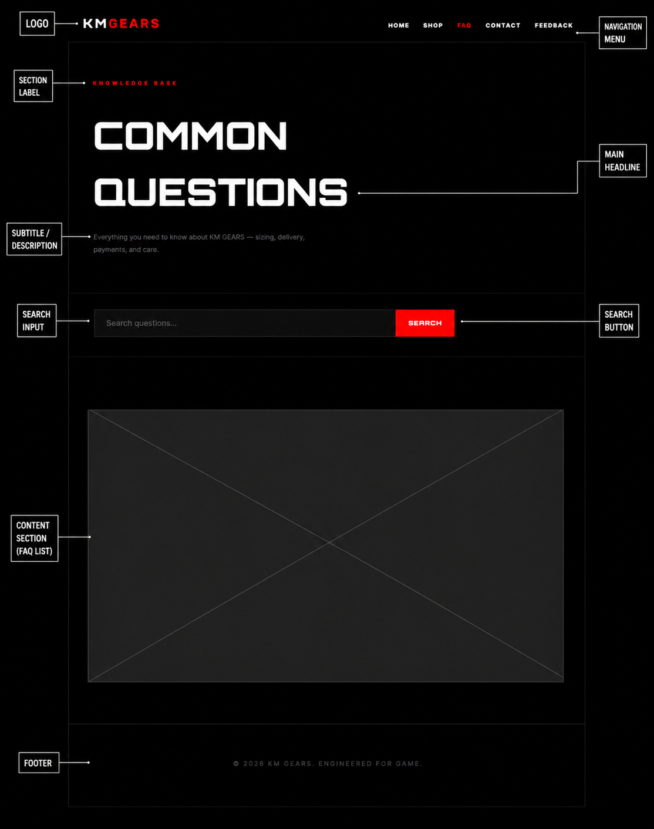
- Section Header: The top of the page maintains the brand's identity with the logo and the full navigation menu (Home, Shop, FAQ, Contact, Feedback).
- Page Label: A small red "KNOWLEDGE BASE" tag is placed at the top left to clearly identify the section's purpose.
- Main Headline: Large, bold text reads "COMMON QUESTIONS," making the page's intent immediately clear to the user.
- Description/Subtitle: A short sentence below the headline explains that the section contains everything a customer needs to know about the brand—specifically mentioning sizing, delivery, payments, and care.
- Search Functionality: A prominent "Search questions..." input bar with a red "SEARCH" button allows users to quickly find specific answers rather than scrolling.
- FAQ List Area: A large content placeholder (marked with an 'X') is designated for the list of specific questions and answers to appear.

CONTACT PAGE
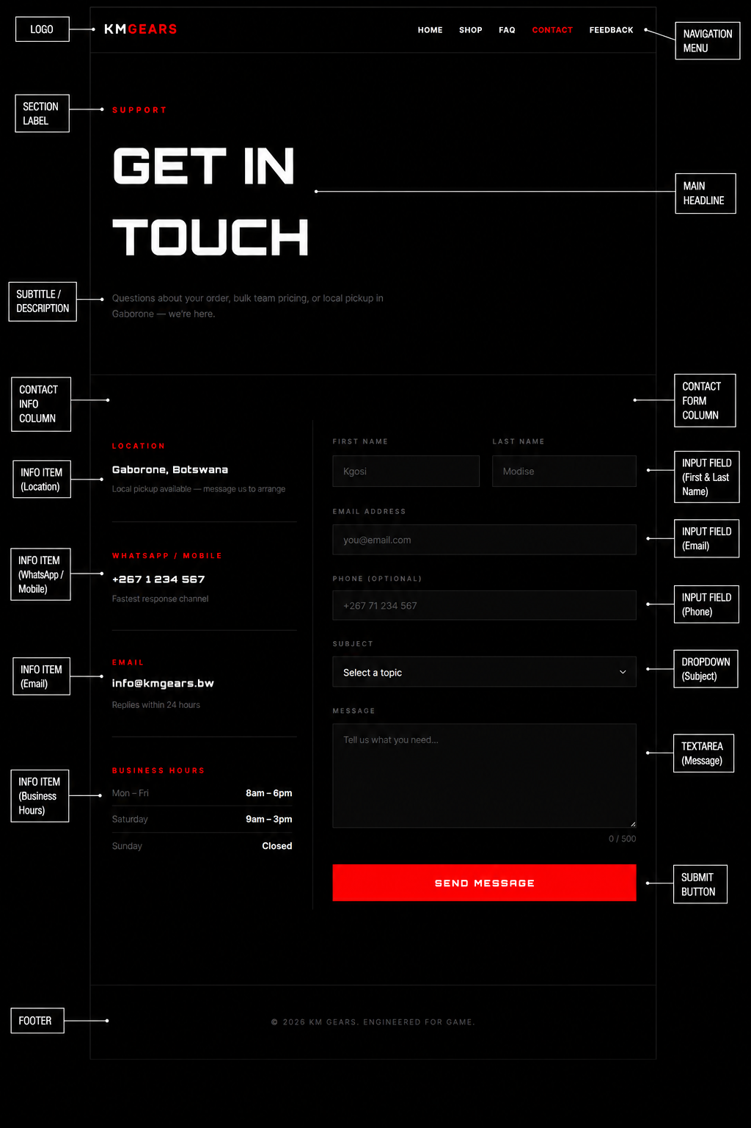

- Header & Navigation: The page includes the standard "KM GEARS" logo and a navigation menu with links to Home, Shop, FAQ, Contact, and Feedback.
- Direct Contact Access: The navigation bar features a dedicated "CONTACT" link, ensuring users can find support options from any page on the site.
- Brand Origins: The wireframe identifies the business's physical presence in Gaborone, Botswana, which provides geographical context for customers seeking local contact or shipping information.
- Integrated Support: The "KNOWLEDGE BASE" section is designed to work alongside the contact page by allowing users to search for answers to common questions regarding delivery and care before reaching out directly.

FEEDBACK PAGE
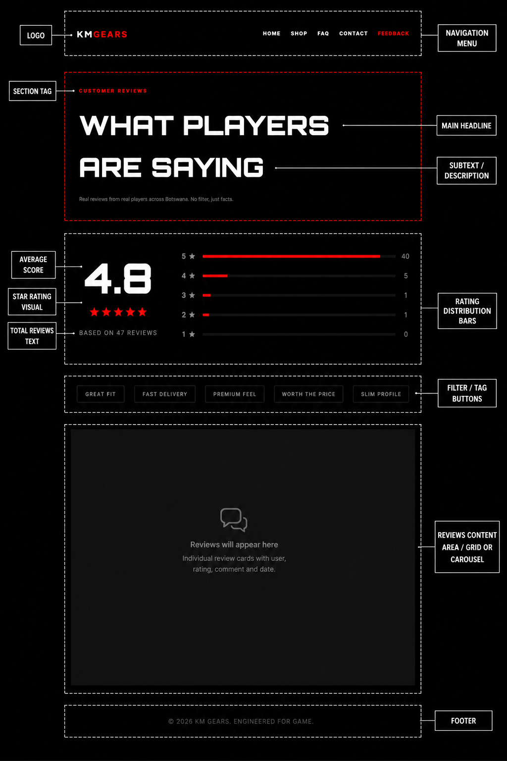
Header & Section Tag: The page features the "KM GEARS" logo and navigation menu, marked with a red "CUSTOMER REVIEWS" tag to identify the section.
Main Headline: A large, bold heading reads "WHAT PLAYERS ARE SAYING," supported by a subtext stating: "Real reviews from real players across Botswana. No filter, just facts".
Rating Overview:
- Average Score: Displays a prominent "4.8" rating.
- Visual Rating: Includes a five-star visual representation.
- Total Reviews: Specifies that the score is "BASED ON 47 REVIEWS".
- Rating Distribution: Shows a bar graph breaking down the number of 5-star to 1-star ratings.
Filter & Tag Buttons: Includes selectable tags for users to filter reviews by specific feedback categories, such as "GREAT FIT," "FAST DELIVERY," "PREMIUM FEEL," "WORTH THE PRICE," and "SLIM PROFILE".
Review Content Area: A designated placeholder where individual review cards—containing the user's name, rating, comment, and date.

